Birla Institute of Technology & Science, Pilani
Work Integrated Learning Programmes Division
Second Semester 2023-2024

Comprehensive Examination
(EC-3 Regular)

Course No. : CSI ZG527
Course Title : Cloud Computing
Nature of Exam : Open Book
Weightage : 40%
No. of Pages = 2

No. of Questions = 5
Duration : 2 ½ Hours
Date of Exam : 19/05/2024 (AN)
Note to Students:
- Please follow all the Instructions to Candidates given on the cover page of the answer book.
- All parts of a question should be answered consecutively. Each answer should start from a fresh page.
- Assumptions made if any, should be stated clearly at the beginning of your answer.

- Answer the below questions (3+3+4=10)
  - State the purpose of having a private docker hub? If I’m connected to a private hub, can I connect to the public repository of docker? Give an example where such a scenario is applicable or not applicable.
Answer :-
Purpose of having a private Docker Hub and connectivity to the public repository
The purpose of a private Docker Hub is to provide a secure and isolated environment to store proprietary or sensitive container images that should not be publicly accessible.
Yes, if connected to a private Docker Hub, one can still pull images from the public repository, provided network access and permissions are configured correctly.
Example Scenario:
Applicable: A company stores custom-built images on a private hub but pulls base images like ubuntu or nginx from Docker’s public repository during the build process.
Not applicable: Environments restricted by security policies disallowing access to public repositories.

b. JVM helps in the portability of java applications and Docker provides containerization. Are these two similar? Explain your answer.
Answer :-
Comparison between JVM and Docker
Similarities:
- Both abstract underlying system differences to ensure portability.
- JVM enables Java applications to run on any OS with a JVM. Docker containers allow applications to run in isolated environments on any Docker-supported system.
Differences:
- JVM operates at the application level, specifically for Java bytecode. Docker operates at the OS level, providing a complete containerized application environment.
Conclusion: While conceptually similar, they operate at different levels of abstraction.

  - Create a docker file to create a container using the latest version of ubuntu. Add commands to run a small script called myscript.py. The myscript.py has the following requirement in terms of libraries.
    - Requests
    - Pytube
Note: The command to install the libraries is “pip install <package name>”. You are to replace this with the packages respectively in your docker file creation.
Answer :-
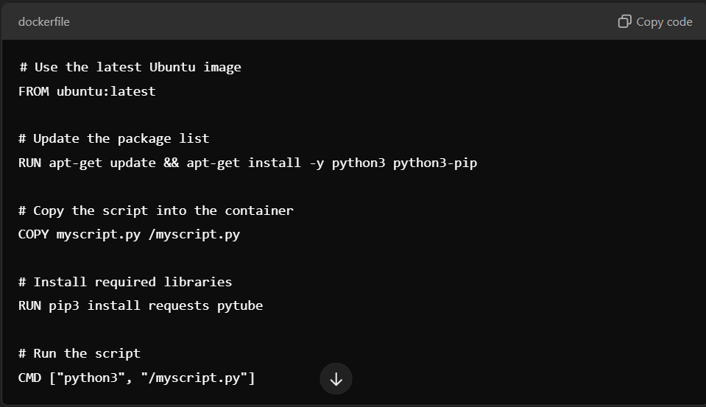

- Modern cloud providers are increasingly advocating the practice of deploying applications which follows the Well architected framework. (WAF). The pillars of a WAF are.
  - Operational Excellence
Automated monitoring and alerting systems.
Version control for infrastructure as code.
  - Security
Secure access using IAM roles.
Encryption of data at rest and in transit.
  - Reliability
Use of auto-scaling groups.
Implementing multi-AZ deployments for redundancy.
  - Performance & Sustainability
Efficient resource utilization using serverless computing.
Periodic reviews for scaling and energy-efficient hardware.

  - Cost Effective
Use reserved or spot instances where feasible.
Monitor usage and eliminate underutilized resources.

A startup company is looking to deploy their application on the cloud using the WAF, based on the above pillars, briefly the factors to consider for each of the above (2*5=10)

- Refer to the below architecture of Messy Inc. They have recently moved their application to the cloud. Answer the questions below (3+2+5 = 10)
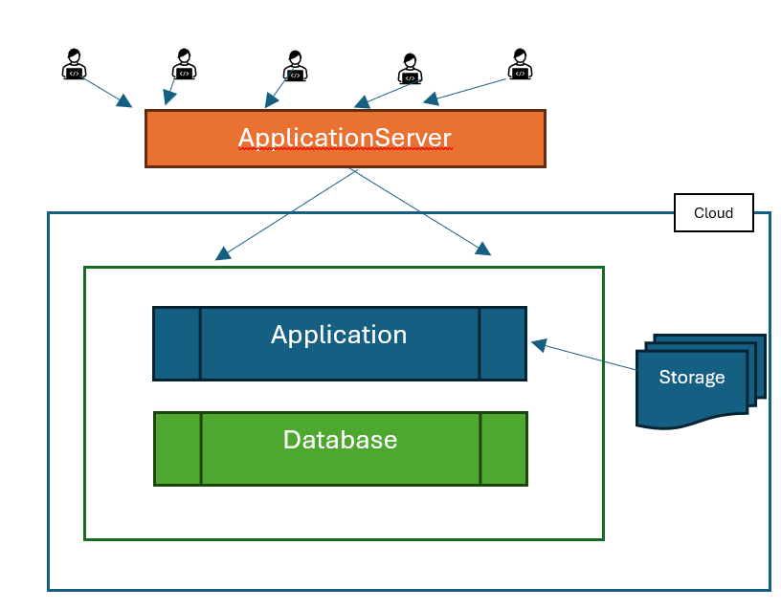
Figure 1:Messy Mart

  - Do you think the above architecture is sustainable? Give reasons.
Sustainability of the architecture
The architecture seems unsustainable if it lacks scalability, security, or redundancy. Issues such as single points of failure, unoptimized databases, or absence of load balancing can contribute.
  - Messy Mart is not able to automatically integrate with third party logistics (delivery partner, shipping partners etc). What would be the best option here?
Integration with third-party logistics
Solution: Implement APIs or middleware solutions that enable seamless integration with third-party logistics partners.
  - The Users of the Messy Mart often complain about sluggish performance, give 5 reasons why the above application is sluggish and provide alternatives.
Reasons for sluggish performance
- Inefficient database queries → Use optimized indexing.
- Overloaded servers → Implement load balancers.
- Poor network architecture → Use a CDN.
- Monolithic design → Break into microservices.
- Lack of caching → Implement in-memory caching.

- From the below conditions for a cloud provider who has a 4-Node cluster, the current occupancy states are given below. Leases are described with start time, duration and whether its pre-emptable. (2+3=5)

Node 1 - L1 (1 pm, 1 hr, yes),
Node 2 - L2 (1.30 pm, 1 hr, No),
Node 3 - L3 (1 pm, 3 hr, No),
Node 4 - L4(now, 2 hr, No).

Now if two new Workload arrives in the form of lease l5 & L6 with description
L5 ( now, 1 hr, No) and
L6 ( 1.30 pm, 2hr , Yes)

Identify what type of lease L5 & L6 are. Briefly state why
Test & evaluate the leases for the BEL pre-emptive condition
Answer –
Identification and Analysis:
L5: Non-preemptable workload. It cannot be interrupted once started.
L6: Preemptable workload. It can be interrupted if higher-priority workloads arrive.
BEL Condition Evaluation:
- Node 4 is not available for preemptable workloads as it already hosts L4, a non-preemptable lease.
- Node 2 and Node 3 are better candidates for preemptable workloads.

- You have been asked to design an “Open File System” which is derived from HDFS architecture with following variances – chunk size of 50 MB, block size of 1 MB. A file of size 500GB needs to be stored on this file system: Marks: 1*5=5
  - How many chunks will be required to store the file?
  - How many blocks will be required to store the file?
  - How many chunk servers will be needed if each server hosts 1000 blocks?
  - How many chunk servers will be needed if each server hosts 100 GB of file?
  - How many chunk servers will be needed if the replication factor is 6 and the capacity of the chunk server is 200 GB?
Answer –
